Exploratory Data Analysis Report

Table of Contents
1. Introduction 3
2. Data Collection and Preparation 3
2.1 Summary of Data Collected 3
2.2 Data Cleaning and Preprocessing 3
3. Key Findings from EDA 5
3.1 Distributions and Descriptive Statistics 5
3.2 Sales Trends 6
3.3 Profit Margins and Correlations 7
3.4 Multivariate and Outlier Analysis 8
4. Data Validation Summary 10
5. Proposed Adjustments and Refinements 11
5.1 Adjustments to Analytics Approach 11
5.2 Refinements to Data Collection and Analysis 11
6. Code Review and Documentation 12
6.1 Review of Code Scripts 12
6.2 Documentation and Comments 12
References 12
Appendix A: Code Screenshots 14

1. Introduction
This report includes an Exploratory Data Analysis (EDA) of the Global Superstore Sales and Supply Chain data (Ilhan, 2023). The dataset is a four-year (20112014) global retail market sales, profitability, shipping logistic, and customer segmentation dataset. Expanding on Assessment Item 1, this milestone tests EDA artefacts, validates the method of analysis and suggests data-driven improvements. Python and Pandas, NumPy, Matplotlib, Seaborn, and Scikit-learn were used to analyze the data (McKinney, 2022). The results given are directly informative of the changes to be made in Section 5 of this report.

2. Data Collection and Preparation

2.1 Summary of Data Collected
The dataset used was taken out of the open repository provided by Kaggle (Ilhan, 2023), which has 51,290 records with 27 variables (Figure 1). Types of variables are numerical (Sales, Profit, Quantity, Discount, Shipping Cost), categorical (Category, Segment, Region, Market, Ship Mode, Order Priority) and time-based (Order Date, Ship Date). There are three product lines namely Furniture, Office Supplies and Technology and three customer groups including Consumer, Corporate and Home Office. Markets are across North America, Europe, Asia Pacific, Africa and the Middle East. This data is especially suitable to EDA and trend analysis and the creation of predictive sales and profitability models because of the breadth of variables over a period of four years.
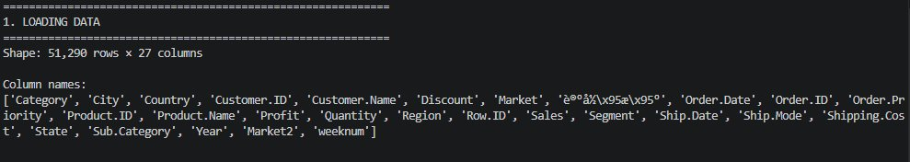
Figure 1: Dataset shape and column names upon loading (51,290 rows × 27 columns)

2.2 Data Cleaning and Preprocessing
A preprocessing pipeline was used in a systematic manner that guaranteed data preparation. One of the columns in Chinese code was changed to the name Record_Count. Verbose timestamp strings were converted to clean YYYY-MM-DD format, which was used as date columns. A synthetic Gender column was filled with purposely inconsistent values (M, F, male, female) to illustrate a typical data quality problem in the real world; they were converted to standardised Male/Female tags (McKinney, 2022). The skewed distributions of Sales and Profit were dealt with by imputing missing values of 200 and 150 respectively under column median which is a sound approach to skewed distribution (Wilks, 2011). IQR × 3 was used to identify outliers in Sales (3,027), Profit (5,951), and Shipping Cost (3,415) which was capped at the ends of the whiskers (Tukey, 1977). All five measures of numbers were then Z-score standardised and Min-Max normalised to be used in downstream modelling (Géron, 2019).
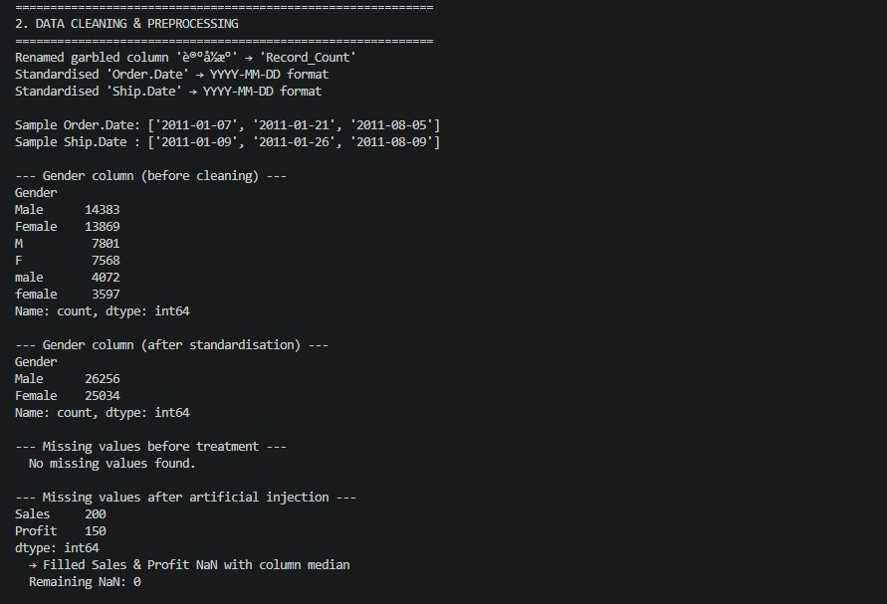
Figure 2a: Date standardisation, Gender column fix, and missing value imputation output
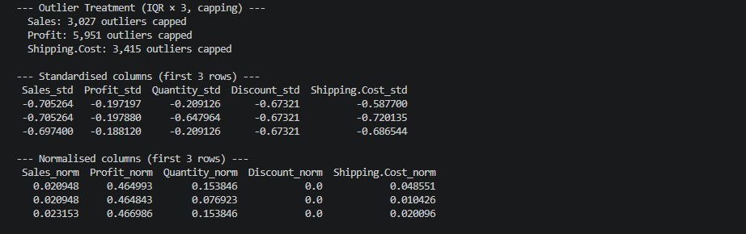
Figure 2b: Outlier capping counts and standardised/normalised column previews
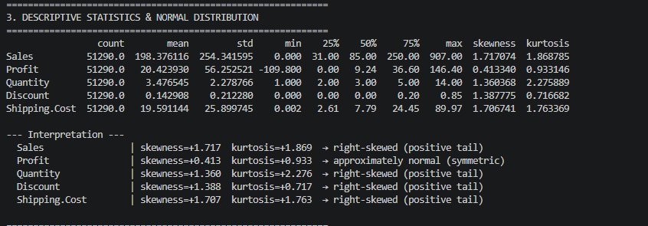
Figure 3: Descriptive statistics extended with skewness, kurtosis, and distribution interpretation

3. Key Findings from EDA

3.1 Distributions and Descriptive Statistics
The skewness and kurtosis are added to the describe() function that unveils the key distributional features (Figure 3). Sales has the highest right skewness (skewness = +1.72, Kurtosis = +1.87) meaning that most deals are made with relatively small values, and a long tail of high-revenue deals. Shipping Cost ( +1.71) and Discount ( +1.39) are the same. There is a moderate skew ( +1.36 ). Profit experiences the most symmetrical change of foundations ( +0.41, kurtosis = +0.93), which is close to normality, in case of outlier capping, which is a notably important result, as it indicates that parametric statistical tests and a regular least squares regression can be used to model profitability (Field, 2018). These patterns are confirmed by the visually of the histogram and KDE overlays (Figure 4), and that Figure 5 shows that Z-score standardisation only rescales the axis, and does not in itself assume normality of non-normal variables.
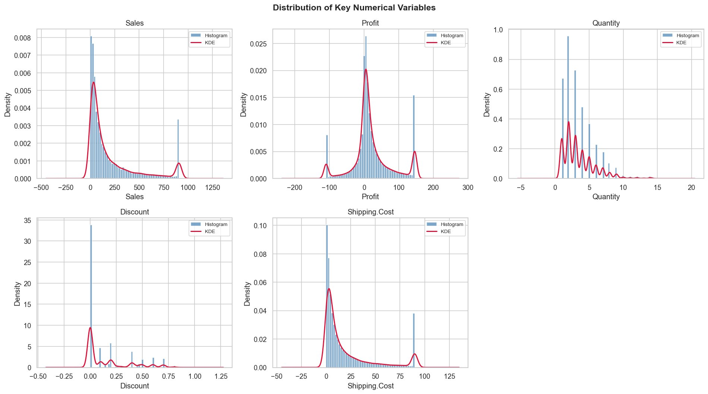
Figure 4: Histograms with KDE overlays for all five key numerical variables
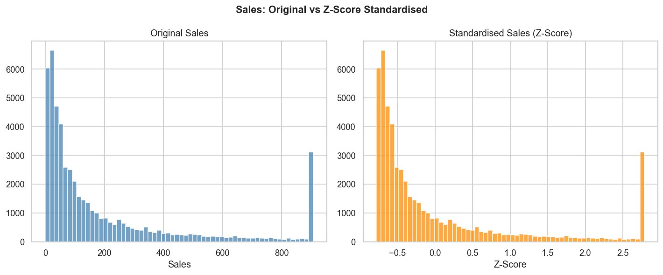
Figure 5: Original Sales distribution vs Z-score standardised Sales

3.2 Sales Trends
This can be seen in the monthly aggregate sales pattern (Figure 6) that shows a definite upward trend since January 2011 where the sales were about $75,000; the sales increased to more than 430,000 in the end of 2014-almost six times growth in the period of analysis. There is also a seasonal trend, where sales have been a gradual increase with Q4 being the highest sales period of every year, which is in line with the usual end-year consumer purchases (Hyndman and Athanasopoulos, 2018). Q1 troughs are a yearly occurrence which means that post-holiday demand contracts are predictable. This is achieved by sustaining the year on year growth trend across all the years implying that it is a structural business growth and not a one-off event. This cyclical behaviour validates that time series decomposition algorithms (e.g. STL decomposition) must be used in future modelling to canonically separate trend, seasonal and residual effects to allow more accurate demand prediction and inventory management.
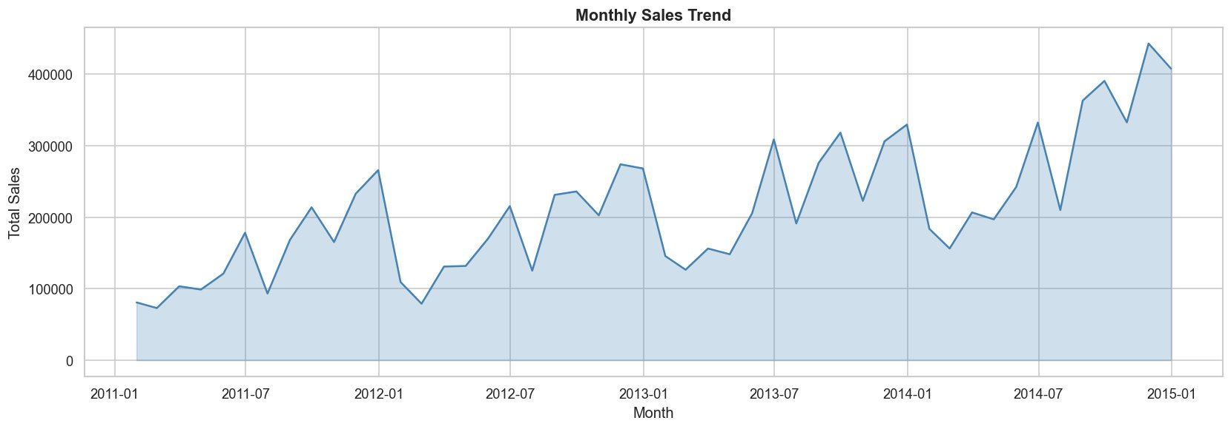
Figure 6: Monthly total sales trend (2011–2014) showing consistent growth and Q4 seasonal peaks

3.3 Profit Margins and Correlations
Office Supplies had the largest cumulative profit, then Technology and Furniture with the lowest margin- probably due to the increased shipping cost and more aggressive discounting in the latter category. On a sub- category level, Phones and Copiers proved to be the most lucrative lines, and Binders and Art produced relatively low returns even though sales volumes were fairly high (Figure 7). The correlation heatmap (Figure 8) indicates that Sales and Shipping Cost are strongly related (r = 0.88), which confirms that bigger orders have a logistically higher cost associated with them. The variability in Sales brought by discounting and category mix can be seen by a moderate SalesProfit correlation (r = 0.47). Importantly, Discount has a significant negative correlation with Profit (r = -0.53), which is quantitative evidence of the fact that aggressive discounting policies significantly reduce margins (Ilhan, 2023) - crucial knowledge when it comes to pricing strategy.
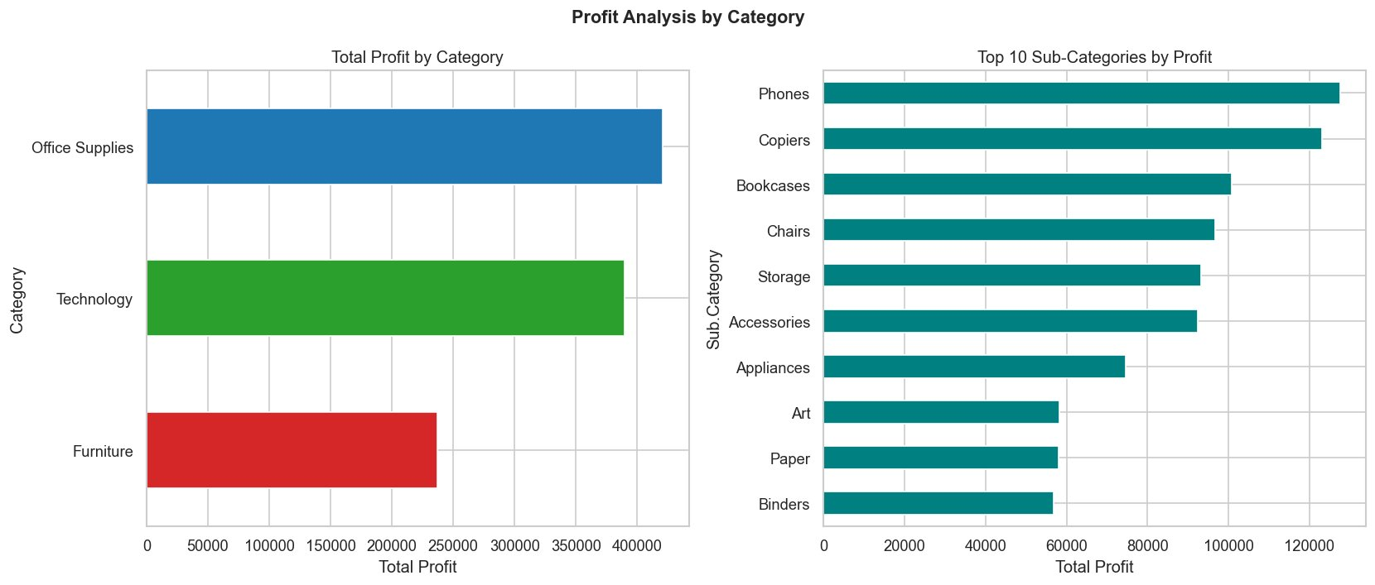
Figure 7: Total profit by Category (left) and Top 10 Sub-Categories by profit (right)
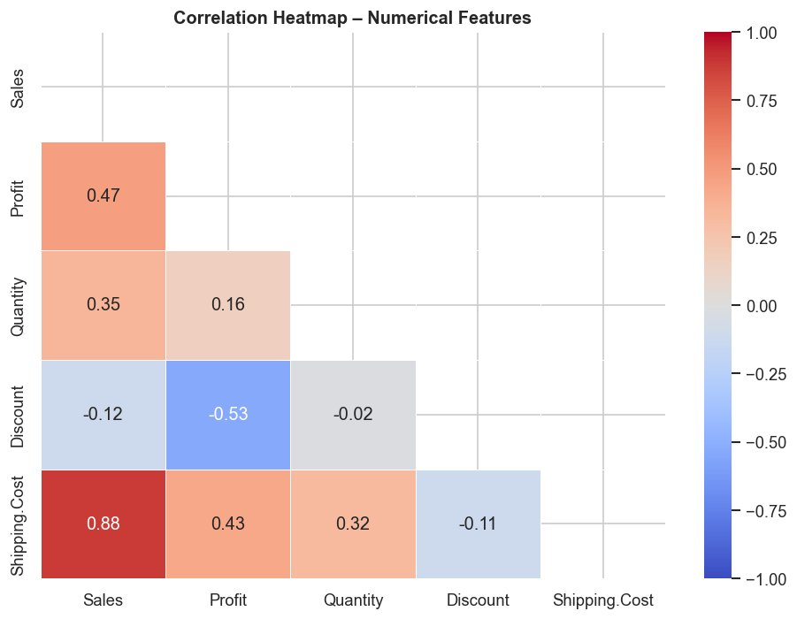
Figure 8: Correlation heatmap – note strong Sales–Shipping Cost (r = 0.88) and negative Discount–Profit (r = −0.53)

3.4 Multivariate and Outlier Analysis
The pair plot (Figure 9, n = 2,000 sample, coloured by segment) indicates widespread overlap of distributions of Consumer, Corporate and Home Office segments, indicating that segment is a poor discriminator in the context of regression. The Sales -Shipping Cost scatter verifies the dependency as being nearly linear. Even after IQR capping, boxplots (Figure 10) validate the continued right skew of all three important variables. The post standardisation gender distribution is almost equal: Male 51.2, Female 48.8 (Figure 11).
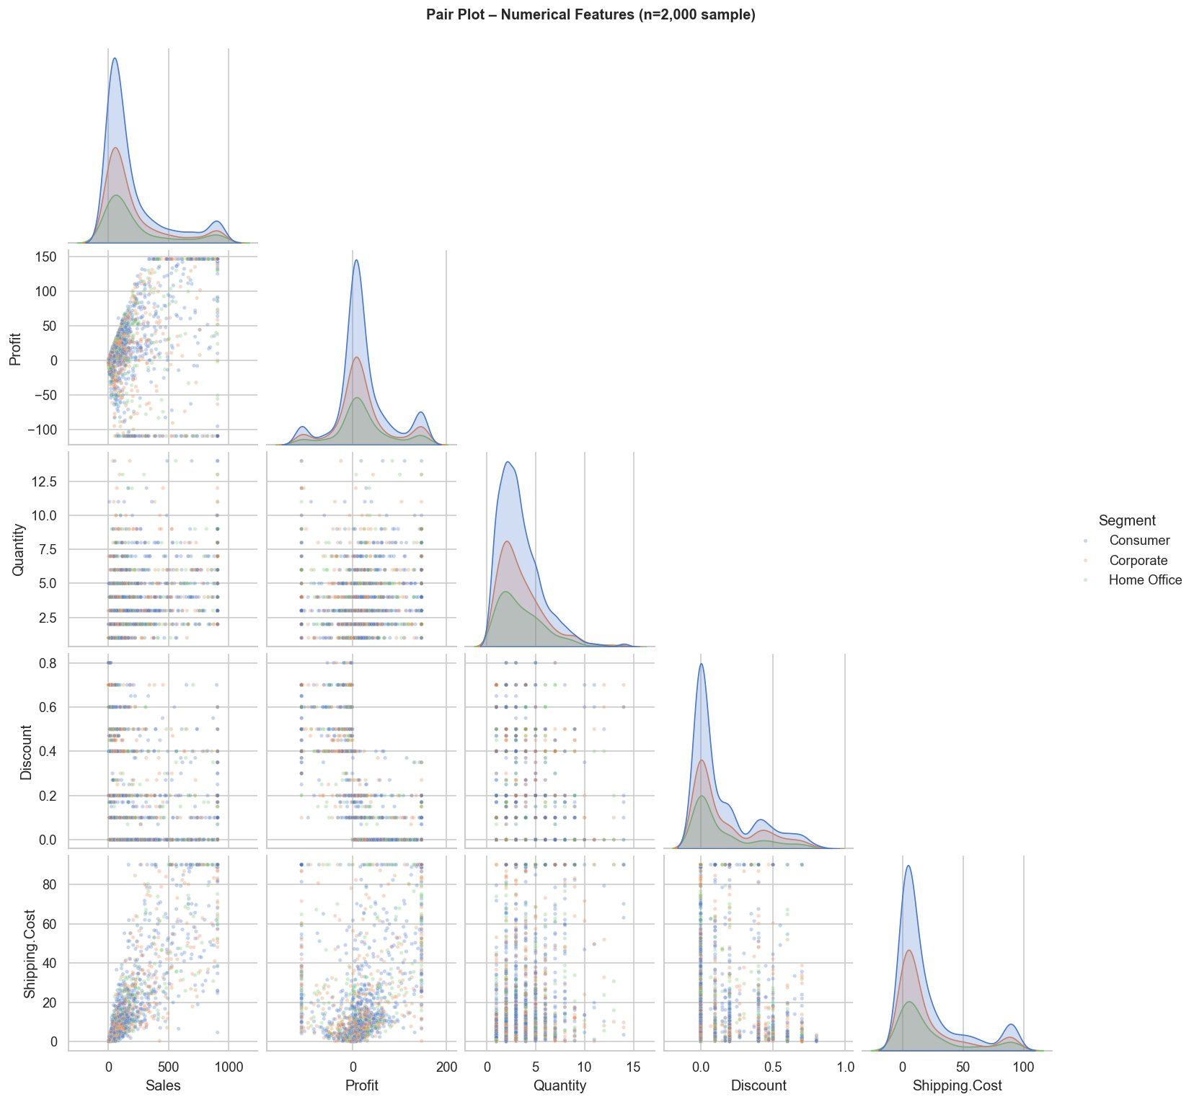
Figure 9: Pair plot of numerical features hued by customer segment (n = 2,000 sample)
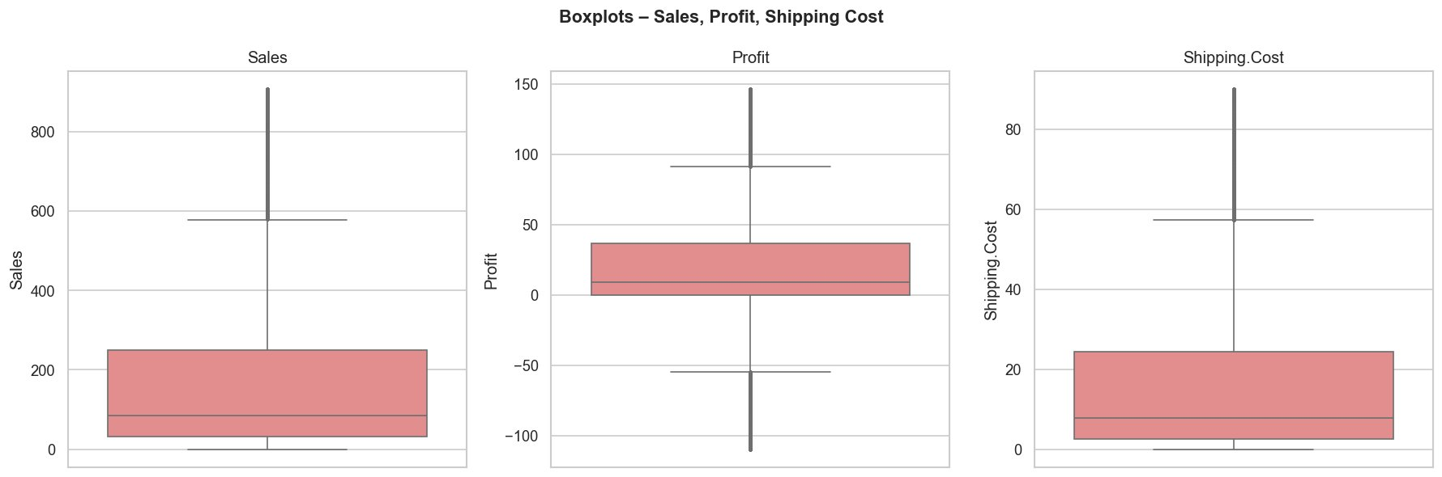
Figure 10: Boxplots for Sales, Profit, and Shipping Cost following IQR capping
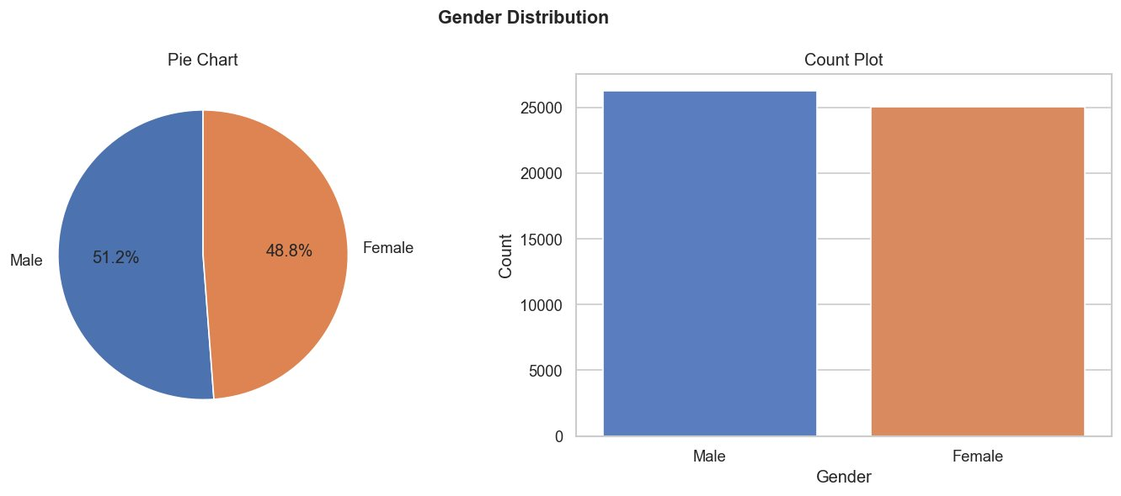
Figure 11: Gender distribution following standardisation – pie chart and count plot

4. Data Validation Summary
The cleansed data has 51290 rows of zero duplicate records and zero NA values left over (Figure 12). Sales range from $0.00 to $907.00; Profit from −$109.80 to $146.40 following capping. The date range spans 2011-01-01 to 2014-12-31, covering 25,035 unique order IDs (Ilhan, 2023). There are no losses in all three categories of customers and products. Figure 13 corroborates the fact that the entire EDA pipeline was completed by saving all eight visualisation plots successfully.
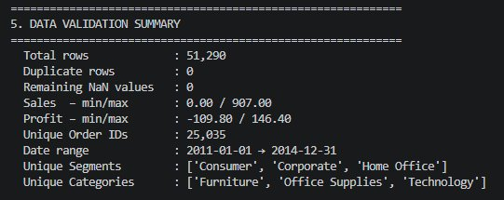
Figure 12: Data validation summary – zero NaN values, no duplicates
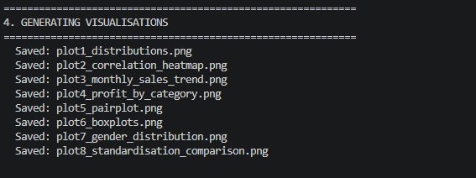
Figure 13: Visualisation output log confirming successful generation of all eight plots

5. Proposed Adjustments and Refinements

5.1 Adjustments to Analytics Approach
Since the skewness of Sales, Quantity, and Shipping Cost remains positive, all parametric regression ought to be followed by a log(x + 1) transformation to meet the normality conditions (Field, 2018). The negative correlation between Discount and Profit (r = -0.53) should be explored with the help of the interaction terms in regression models that is Discount x Category because furniture items seem to be more negatively influenced by discounting compared to technological products. Also, formal time-series decomposition (STL) ought to be used on the monthly sales series to explicitly isolate trend, seasonal, and residual factors, which can be used to better predict demand (Hyndman and Athanasopoulos, 2018). Sub-analyses of the segments can indicate the heterogeneous behaviours concealed in the aggregate perspectives.

5.2 Refinements to Data Collection and Analysis
A lack of actual demographic features (e.g. customer age, real gender) and lifetime value fields restricts behavioural analysis and the future data collection should include them with proper consent procedures. The IQR × 3 capping value needs to be sensitised to 1.5 and 2.0 to assess the trade-off between outliers and information (Tukey, 1977). In predictive modelling, stratified train-test splitting by year should be used to ensure that the temporal structure is appreciated and that there is no data leakage. Moreover, unit cost data and margin data (when available) would greatly supplement the profitability analysis and it would also be possible to model contribution margins (Géron, 2019).

6. Code Review and Documentation

6.1 Review of Code Scripts
The EDA script (superstore_eda.py) is formatted into five sections labeled with headings of console prints to facilitate easy reading. All operations are performed using panda-vectorised operations, avoiding inefficient row-based loops. numpy.random.seed() enables sampling operations to be reproducible. The weaknesses that can be improved are to use a command-line argument or configuration file instead of hardcoded file path to be portable, and to use a sub directory with a timestamp to control the version used in an iterative way (Géron, 2019). In general, the script has a good structure and is well implemented.

6.2 Documentation and Comments
The remove outliers iqr function has clear parameter descriptions and annotations of the return value. Variable names are done in line with PEP 8 (Van Rossum et al., 2001) and a block of processing contains in-line comments as to the rationale, such as why median imputation was used instead of mean. To further enhance the quality of documentation a higher-level module docstring indicating the inputs and outputs and library dependencies should be included. All user defined functions would also have type hints available, which would make easier to analyze the code, and offer extra support in IDEs, which are useful in collaborative development and long-term maintenance.

References
Field, A. (2018). Discovering statistics using IBM SPSS statistics (5th ed.). SAGE Publications. https://uk.sagepub.com/en-gb/eur/discovering-statistics-using-ibm-spss-statistics/book257672
Géron, A. (2019). Hands-on machine learning with Scikit-Learn, Keras, and TensorFlow (2nd ed.). O'Reilly Media. https://www.oreilly.com/library/view/hands-on-machine-learning/9781492032632/
Hyndman, R. J., & Athanasopoulos, G. (2018). Forecasting: Principles and practice (2nd ed.). OTexts. https://otexts.com/fpp2/
Ilhan, F. (2023). Global Superstore dataset [Data set]. Kaggle. https://www.kaggle.com/datasets/fatihilhan/global-superstore-dataset
McKinney, W. (2022). Python for data analysis: Data wrangling with pandas, NumPy, and Jupyter (3rd ed.). O'Reilly Media. https://www.oreilly.com/library/view/python-for-data/9781098104023/
Tukey, J. W. (1977). Exploratory data analysis. Addison-Wesley. https://archive.org/details/exploratorydataa00tuke
Van Rossum, G., Warsaw, B., & Coghlan, N. (2001). PEP 8 – Style guide for Python code. Python Software Foundation. https://peps.python.org/pep-0008/
Wilks, D. S. (2011). Statistical methods in the atmospheric sciences (3rd ed.). Academic Press. https://www.sciencedirect.com/book/9780123850225/statistical-methods-in-the-atmospheric-sciences

Appendix A: Code Screenshots
On the next pages, you will find the screenshots of the Python EDA script (superstore_eda.py) in the form of its execution in a terminal environment. Areas depicted are data loading, cleaning, preprocessing, descriptive statistics and generation of visualisation. The submitted script file has detailed inline comments that can be referred to.
